SAVE THE DATE
Fall Photography Walk & Shoot at Sagamore Hill
Saturday, October 29, 2022
10:00 am to Noon

Join our team of professional and amateur photographers for some light-hearted fun on a shoot and walk tour of the grounds and nature trails.
We will group by families with children and adults; from experienced to novice and by interest: landscape, architecture, and nature. Groups are limited to 6 people per group.
Meet at the Picnic Area at 10:00 am to sign in.

Please call 516-922-4788 or email to SAHI_Information@nps.gov if you need assistance with registration.

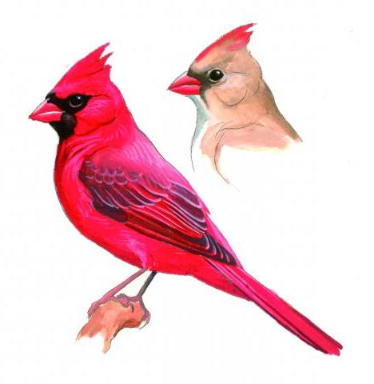
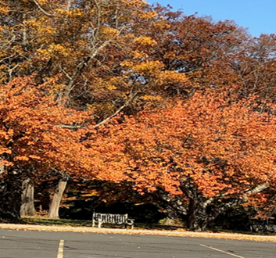
Registration in late September
Sponsored by:
The Theodore Roosevelt Legacy Partnership
Contact us at: TRLegacyPartnership@gmail.com or visit our webpage: www.trlegacypartnership.org

