War Service, Theodore Sr., and Theodore Jr. – from Delanceyplace.com
6/01/20

Today's selection -- from The Rise of Theodore Roosevelt by Edmund Morris. Theodore Roosevelt, Sr., father to the future president, spent his years in the Civil War persuading soldiers to set aside voluntary pay deductions for family support, a novel concept in war:

"He had spent most of the summer agonizing, to the tramp of mustering regiments, over what role he should play in the war. Although he was not yet thirty, and in prime physical shape, his domestic situation was such that he could not contemplate taking up arms. Under his roof lived three women -- Grandmother Bulloch, Mittie, and her sister Annie -- who owned slaves and a plantation and were passionate in their support of the Confederacy. (Mittie allegedly once hung out the Stars and Bars after a Southern victory.) Two of Mrs. Bulloch's sons were fighting for the South. Could he fire upon, or receive the bullets of, his brothers-in-law? In anguish Theodore Senior did what many of his wealthy friends were doing. He hired a substitute soldier.

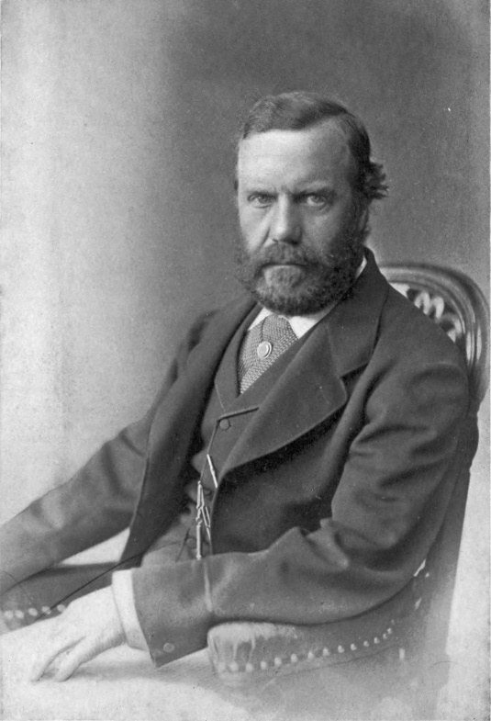

Theodore Roosevelt Sr.

"Yet as a strong Lincoln Republican, his 'troublesome conscience' would not let him rest. A certain strain developed between himself and his wife, although their mutual love never wavered. 'I wish we sympathized together on this question of so vital moment to our country,' he told her gently. 'I know you cannot understand my feelings and of course do not expect it.' Eventually he announced that he had decided to aid the war effort in a civilian capacity, and, true to his nature, soon found a charitable cause.

"Already, in these early days of war, millions of government dollars were flowing through the pockets of Union soldiers and into the hands of sutlers, who infested military camps, hawking bottles of liquor hidden in loaves of bread. The sutlers charged such exorbitant prices that their customers soon had no money left to send home to their families. It was to right this wrong that Theodore Senior set off to Washington, and, conquering his natural distaste for politics, began to lobby for remedial legislation.

"With two colleagues, he drafted a bill for the appointment of unpaid Allotment Commissioners, who would visit all military camps and persuade soldiers to set aside voluntary pay deductions for family support. This proposal, which eventually became standard military practice, seemed eccentric, if not downright suspect, in 1861, as a family friend recalled many years later:

For three months they worked in Washington to secure the passage of this act -- delayed by the utter inability of Congressmen to understand why anyone should urge a bill from which no one could selfishly secure an advantage. When this was passed he was appointed by President Lincoln one of the three Commissioners from this State. For long, weary months, in the depth of a hard winter, he went from camp to camp, urging the men to take advantage of this plan; on the saddle often six to eight hours a day, standing in the cold and mud as long, addressing the men and entering their names. This resulted in sending many millions of dollars to homes where it was greatly needed, kept the memory of wives and children fresh in the minds of the soldiers, and greatly improved their morale. Other States followed, and the economical results were very great.

"Lincoln's private secretary, a round-headed, slant-eyed youth named John Hay, proved a willing conduit to the President, and Theodore Senior made the most of his assistance. It is a great luxury to feel I am at last doing something tangible for the country,' he wrote Mittie. Homesickness nevertheless tugged at him. 'I cannot,' he confessed, 'get Bammie's and Teedee's [sic] faces, as they bid me goodbye at the door, out of my mind.'

"It is significant that Theodore Junior [Teedee], when he came to write his own autobiography, made no mention whatsoever of his father's role in the Civil War -- his invariable practice being to leave painful memories unspoken, 'until they are too dead to throb.' To serve in mufti was, in his opinion, something less than manly, and his tacit disapproval of the episode is the only indication that Theodore Senior was ever less than a god to him. Many biographers, including his own sister, have suggested that guilt over that substitute soldier explains the future Rough Rider's almost desperate desire to wage war. He himself, at the age of three, made no bones about his wish to be at the front. 'Teedie was really excited,' wrote Annie Bulloch, 'when I said to him, "Darling, I must fit this zouave suit ..." his little face flushed up and he said, "Are me a soldier laddie?" I immediately took his own suggestion and told him he was and that I was the Captain.'"

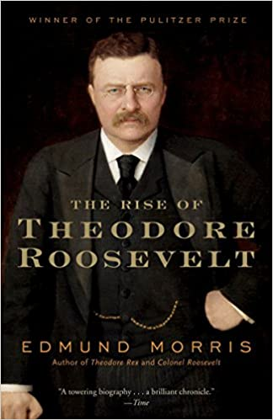

The Rise of Theodore Roosevelt

Author: Edmund Morris
Title: The Rise of Theodore Roosevelt
Publisher: Modern Library
Date: Copyright 1979 by Edmund Morris
Page(s): 8-10

